

**Department of Computer Science**

**American International University-Bangladesh**

**Final Term Project -Report**

**Course Name: Machine Learning**

**“A report on Osteoarthritis detection”**

**Supervised By:**

Prof. Dr. Md. Asraf Ali

Associate Professor, Computer Science

**Submitted By:**

Section: D

**1.Project Objective:**

The objective of this project is to develop a model for the detection of osteoarthritis using machine learning techniques. The aim is to improve the accuracy and efficiency of osteoarthritis detection, enabling early intervention and personalized treatment strategies.

1. Early Identification: The primary objective is to detect osteoarthritis at an early stage, enabling timely intervention and management. Early detection allows for the implementation of preventive measures and appropriate treatment strategies to slow down disease progression and alleviate symptoms.
2. Accurate Diagnosis: Another objective is to improve the accuracy of osteoarthritis diagnosis. Accurate detection ensures that individuals are correctly identified as having osteoarthritis, preventing misdiagnosis or delayed diagnosis. This objective involves developing robust algorithms and diagnostic criteria that consider various clinical, imaging, and biomarker data.
3. Personalized Treatment: Osteoarthritis detection aims to enable personalized treatment approaches tailored to individual patients. By accurately identifying and characterizing the disease, healthcare providers can offer targeted interventions, such as specific medications, physical therapy, or lifestyle modifications, based on the patient's unique needs and disease severity.

**2.Methodology:**

**2.1 Data Collection Procedure:**

The project will utilize a dataset comprising clinical and imaging data of patients diagnosed with osteoarthritis.

The data will be collected from healthcare institutions, including medical records, imaging reports, and patient demographics.

**2.2 Data Validation Procedure:**

The collected data will undergo a validation process to ensure its quality and reliability.

Data validation will involve checking for missing values, outliers, and inconsistencies within the dataset.

**2.3 Data Preprocessing and Normalization:**

Data preprocessing techniques will be applied to clean and prepare the dataset for analysis.This includes handling missing values, outlier detection, and normalization of numerical features.Data preprocessing and normalization are critical steps in the development and evaluation of machine learning models for osteoarthritis detection. Preprocessing techniques such as data cleaning, feature selection, and feature engineering can help to reduce noise and irrelevant data, and highlight the most informative features for the model. Normalization methods such as Z-score normalization, min-max normalization, or robust normalization can be applied to ensure that the data is on the same scale, facilitating the comparison and combination of data from different sources. Preprocessing and normalization can improve the accuracy and reliability of machine learning models for osteoarthritis detection, by reducing the impact of noise, missing data, and variation in data format or scale.



Normalize the images to a standard scale and resolution.Split the dataset into training, validation, and testing sets.

**2.4 Feature Extraction Procedure:**

Relevant features will be extracted from the dataset to capture important information for osteoarthritis detection.

Feature extraction techniques, such as statistical measures, frequency analysis, or imaging feature extraction, will be employed.

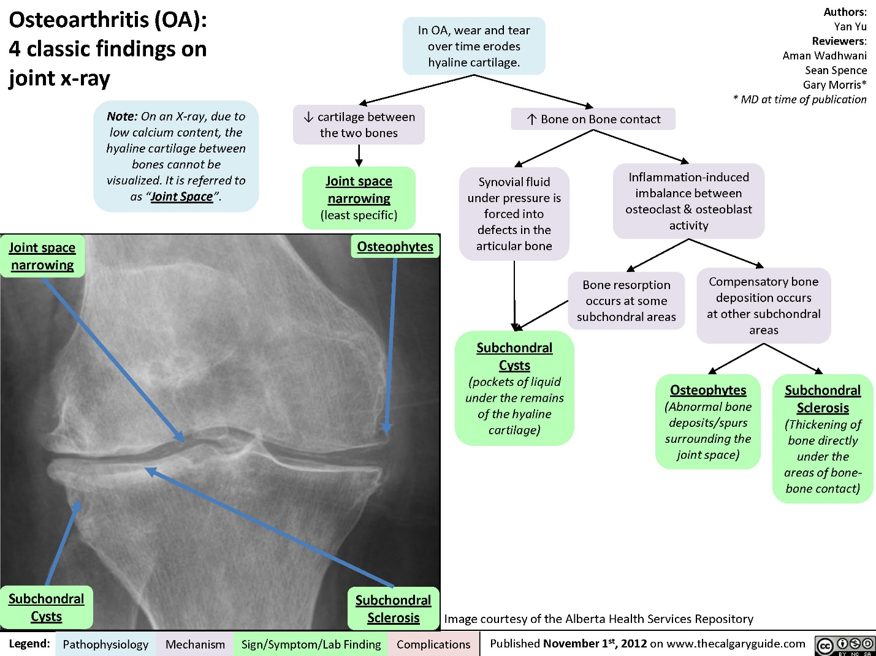

**2.5 Classification Algorithms:**

A Convolutional Neural Network, also known as CNN or ConvNet, is a class of neural networks that specializes in processing data that has a grid-like topology, such as an image. A digital image is a binary representation of visual data.Various machine learning classification algorithms, such as Support Vector Machines (SVM), Random Forest, or Neural Networks, will be implemented.

These algorithms will be trained and tested using the prepared dataset to classify individuals as either having osteoarthritis or not.

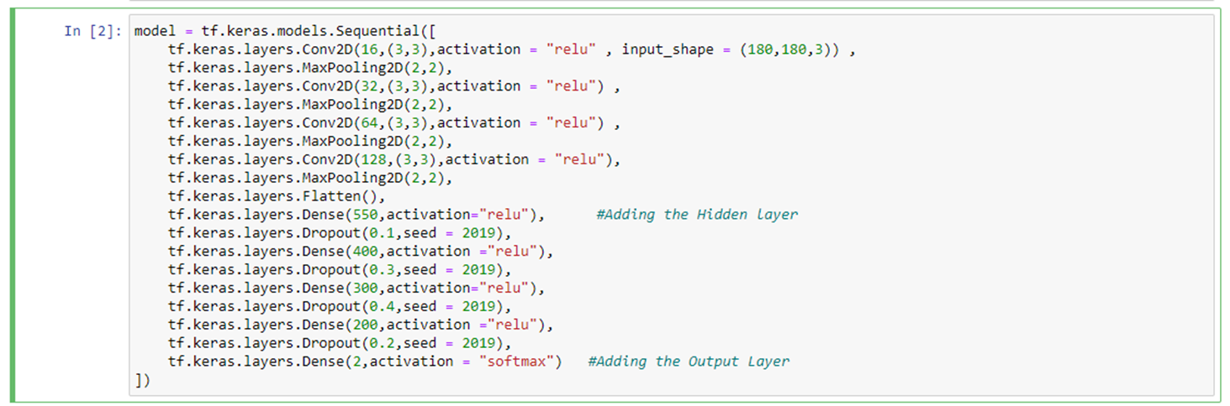

**2.6 Data Analysis Techniques:**

Data analysis techniques, such as cross-validation, performance evaluation metrics, and statistical analysis, will be employed to assess the performance of the classification algorithms

**Normal People Data:**



**Osteoarthaitis Data:**



**2.7 Block Diagram and Workflow Diagram of Proposed Model:**

A block diagram and workflow diagram will be developed to illustrate the proposed model for osteoarthritis detection, highlighting the various stages and components involved.

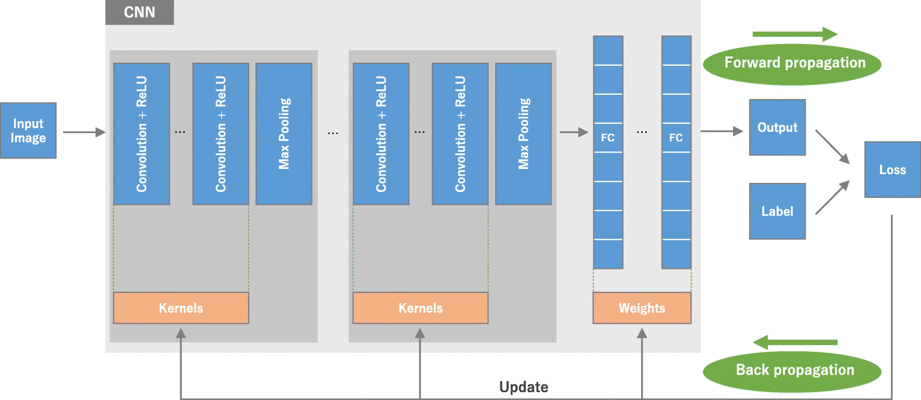

CNN is a type of deep learning model for processing data that has a grid pattern, such as images, which is inspired by the organization of animal visual cortex [13, 14] and designed to automatically and adaptively learn spatial hierarchies of features, from low- to high-level patterns.

CNN is a mathematical construct that is typically composed of three types of layers (or building blocks): convolution, pooling, and fully connected layers. The first two, convolution and pooling layers, perform feature extraction, whereas the third, a fully connected layer, maps the extracted features into final output, such as classification.

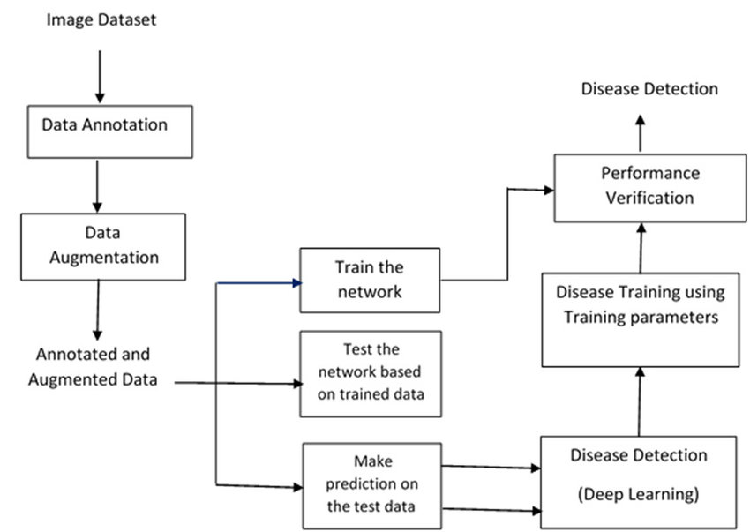

CONVOLUTIONAL NEURAL NETWORKS CNNs [3] are a type of deep artificial neural networks, used mainly to identify and cluster images, and perform object recognition. A CNN consists of image processing layers and neural network layers namely: (a) convolutional layer, (b) pooling layer, (c) flattening layer, (d) ReLU layer, and (e) Softmax layer.

**2.8 Experimental Setup and Implementations:**

The project will utilize programming languages (e.g., Python), machine learning libraries (e.g., scikit-learn), and data analysis tools to implement the proposed model.

The hardware and software requirements for the experimental setup will be outlined.

**Results and Discussion:**

**3.1 Results Comparison:**



This is the average accuracy we got from our model. An average accuracy of 0.67% in osteoarthritis detection indicates that the model's performance is better than random guessing but may still have room for improvement.

The results obtained from the classification algorithms will be compared to evaluate their performance in osteoarthritis detection.

Metrics such as accuracy, precision, recall, and F1-score will be utilized for comparison.

**3.2 Confusion Matrix Analysis**:

Confusion matrices will be generated to analyze the true positive, true negative, false positive, and false negative rates of the classification algorithms.

**3.3 Graphical Representation of Results:**

Graphical representations, such as bar charts or line graphs, will be utilized to visually present the performance and comparative analysis results.

Conclusion and Future Recommendations:

The project will conclude with a summary of the findings and their implications for osteoarthritis detection.

Recommendations for future improvements, such as incorporating additional features, exploring advanced machine learning techniques, or considering longitudinal data analysis, will be provided.

By implementing this project, we aim to enhance osteoarthritis detection, enabling early intervention and personalized treatment strategies. The results obtained will contribute to the growing body of knowledge in the field of osteoarthritis detection and pave the way for further research and advancements.

**Conclusion and Future Recommendations:**

The project will conclude with a summary of the findings and their implications for osteoarthritis detection.

Recommendations for future improvements, such as incorporating additional features, exploring advanced machine learning techniques, or considering longitudinal data analysis, will be provided.

By implementing this project, we aim to enhance osteoarthritis detection, enabling early intervention and personalized treatment strategies. The results obtained will contribute to the growing body of knowledge in the field of osteoarthritis detection and pave the way for further research and advancements.